**LEP – Sub Committee**

**LEP - Lancashire Skills and Employment Advisory Panel**

**Private and Confidential: NO**

**Date:**

**Up-date from the Lancashire Skills & Employment Hub**

Appendices A, B & C refer

**Report Author:** ,

|  |
| --- |
| **Executive Summary** This paper provides an overview of activity since the last formal committee meeting in April 2018. The paper also provides details of the development of the Apprenticeship Action Plan, which is a joint plan with the Lancashire Leaders and the Lancashire Work Based Learning Forum, and was presented in draft to the last committee meeting. **Recommendation** The Skills and Employment Advisory Panel is asked to:   1. Note the update 2. Approve the Apprenticeship Action Plan |

1. **Careers Education, Information, Advice and Guidance**
   1. The Lancashire Enterprise Adviser Network has grown from 121 schools and colleges in April 2018, to 130. Of the 130, 119 have been matched with at least one volunteer business leader (Enterprise Adviser). Since the start of the 2018/19 academic year (Sept 2018 – March 2019), there have been approximately 100,000 employer encounters involving young people from across the County. Typical encounters range from traditional careers fairs, interview days, speed networking, enterprise weeks, dragons’ den, apprenticeship assemblies and guest speakers.
   2. The focus of the Enterprise Adviser Network is supporting schools to achieve Benchmarks 5 and 6. Benchmarks 5 and 6 are ensuring that young people have a minimum of one employer encounter from Year 7 to Year 13, and that one of those encounters is in the workplace. The Grant Offer from the Careers and Enterprise Company (CEC) has targets for achievement of these Benchmarks, with 50% of schools and colleges within the network to achieve the Benchmarks by August 2019 and 75% by August 2020. The current achievement level is 54% (52*%[1]*) against Benchmark 5 and 47% (49%) against Benchmark 6; the reduction is due to a recent loss of 2 Enterprise Advisers from schools that currently meet Benchmark 6, as reporting does not include schools without a matched Enterprise Adviser.
   3. It has been identified nationally by the CEC that for the schools and colleges to achieve Benchmarks 5 & 6, there needs to be approximately 5 million employer encounters per year across England. At the moment, it is estimated to be 1.7m short. Therefore, the CEC has launched the ‘Give an Hour’ campaign which is a drive to increase the number of employers willing to support their local schools and colleges. The campaign is being run in collaboration with willing LEPs across the Country and is targeted at Small to Medium Enterprises (SMEs).
   4. The ‘Give an Hour’ campaign for Lancashire was launched in May and is being led by Inspira in partnership with Lancashire Skills Hub. It will be integrated into the wider re-branding and launch of the Lancashire Skills Pledge. The ‘Give an Hour’ campaign will be run over a 2-month period and a report on its activity and outcomes will be presented in the next update.
   5. A press release has been issued by the LEP, in partnership with Inspira and has featured in a number of local newspapers and publications, for example: <https://www.lancashirebusinessview.co.uk/latest-news-and-features/small-businesses-urged-to-give-an-hour> and there is significant twitter activity @LancsSkillsHub. Members of the panel are asked to share the press release with groups and forums and on their social media platforms to help spread the word to SMEs across Lancashire. Pupils at St Christopher's featured in the Press Release, reaching out to Lancashire employers:



* 1. Preparation is underway for the Annual Lancashire Enterprise Adviser Network and Careers Hub conference, which will take place on the 20th June 2019 at Park Hall Hotel. Speakers confirmed include Professor Sir John Holman (Senior Education Adviser, Gatsby Charitable Foundation) and John Yarham (Deputy Chief Executive, Careers and Enterprise Company).
  2. All schools/colleges have continued to engage with the Careers Hub during the spring term. All schools/colleges have attended area Hub meetings, completed Compass and Tracker and developed plans alongside their Enterprise Advisers and Enterprise Coordinators to ensure continuous progression against the 8 Benchmarks. An average of 4 Gatsby Benchmarks have been achieved across the Schools and Colleges within the Careers Hub, which is the target for this academic year. Current performance puts Lancashire joint second against the CEC data for the 20 pilot Careers Hubs across the Country.
  3. The Lead School is providing significant support to schools across the Careers Hub, including hosting Hub meetings, communicating with fellow Head Teachers, supporting other schools on a one to one basis based on need and piloting innovative practice against Gatsby Benchmark 4.
  4. Five new Cornerstone employers have been recruited across Blackpool, Burnley and Pendle. The employers are BAE Systems, Sandcastle Waterpark, Silentnight, Burnley Council and Pendle Council. The role of a Cornerstone employer is to advocate to fellow businesses to engage with schools and colleges in their local area.

**2. European Structural Investment Funds (ESIF)**

2.1 Work has continued with the DWP Managing Authority to plan direct calls to enable the allocation of remaining funds in the European Social Fund (ESF) programme. It was agreed at the ESIF Committee in May that calls for 1.4, 2.2 and 2.1 would be scheduled throughout the year, in May, August and December respectively. The 1.4 call was launched in the last week of May. A workshop is being planned with partners to illicit discussion in relation to 2.2 and 2.1. There is on-going discussion regarding allocations to opt-ins and the desire to extend delivery against the Education and Skills Funding Agency (ESFA) opt-in beyond July 2021. Negotiations are underway with the ESFA and the DWP in regard to varying the current Memorandum of Understanding.

2.2 The ESFA opt-in projects, as detailed in the last update, commenced on the 1st April. Steering Groups are continuing to provide oversight, and are providing support to the projects in the first phase of delivery. Development Plans have also been drafted and are included for sign off under a separate agenda item. There are on-going negotiations in regard to the extension of the Big Lottery op-in, Building Better Opportunities, and the extension of projects.

2.3 The Escalate on-line referral tool to support people on their journey into work was launched in April 2018. Phase two of the system is in the final stages of development and will also include the new ESFA Opt-In projects including Skills Support for Redundancy.

2.4 From April 2018 until 14th March 2019, 2387 searches were made on the Escalate system. Since March 14th until 21st May a further 133 searches were made. The support requests which are the most requested remain, confidence, mental health support, support with IT and the use of IT, and support with CVs and interviews. A gap analysis report is being produced to support activity within the Lancashire Adult Skills Forum.

2.5 The Employer Skills Forum brings together partners to ensure that ESF provision for employers across Lancashire supports the strategic outcomes defined within the Lancashire LEP Skills and Employment Strategic Framework and adds value. The forum held a joint event with BOOST on 13th May which brought together representatives from ESF funded skills projects that are employer facing and the BOOST business support projects. The focus of the event was to ensure the attendees gained a full understanding of the skills support offer for businesses and the business support offer by BOOST and to build on the work already undertaken in facilitating referrals. Over 60 people attended the event including representatives from the skills projects, BOOST Business Relationship Managers, and Economic Development representatives from the districts, as well as other intermediary organisations. Attached at Appendix A is a diagram that was presented at the event which provides an overview of the ESF project skills offer for employers to support effective referrals and effective employer engagement.

**3. City Deal**

3.1 A City Deal review is currently underway and a new Heads of Terms is being progressed under the guidance of consultants, Steer Economic with the aim of bringing forward a package of improvement proposals to the City Deal Executive and Stewardship Board in July. The outcome of the review will be fed into the City Deal Skills and Employment Steering Group to help shape future activity.

3.2 Following the announcement of the revised proposals at the Lancashire Central strategic site at Cuerden, the Skills and Employment Hub will be working closely with the City Deal Project Team to ensure that the site wide Employment and Skills plan is revised to reflect the new proposals.

3.3 On the 3rd May Seddon held a 'Meet the Buyer' event hosted by Preston's College to highlight some of the supply chain opportunities that will be available through the development of the Goosnargh City Deal residential site. The project will deliver a wide range of employment and skills outputs which have been set out in the projects Community Commitment Charter.

3.4 As highlighted in the Skills and Employment Board papers for 21st November 2018, the City Deal 'Bridge the Gap' programme continues to go from strength to strength. Over the 2018/19 academic year the programme has been delivered to Year 9 and 10 pupils at a total of 17 schools across the City Deal area of Central Lancashire. One of the schools that participated in this year's programme was Longridge High School (see Appendix B).

3.5 A full evaluation report will be prepared at the end of the current academic year to highlight the numbers of schools and pupils engaged during the 2018/19 academic year.

**4. Growth Deal**

4.1 As outlined in the Skills and Employment Board papers in November 2018, the Growth Deal programme has continued to deliver positive employment and skills outputs across the project portfolio which are now being monitored using the National TOM's Framework.

4.2 As requested at the Growth Management Board in December 2018, the Skills and Employment Hub have carried out detailed Social Value assessments of two projects within the project portfolio, Blackpool Tramway Extension and UCLan's Engineering Innovation Centre.

4.3 These case studies have been developed using the National TOM's methodology outlined in the November Skills and Employment Board papers to measure the outcomes delivered across a range of metrics including workforce development, apprenticeship provision, providing employment opportunities for priority groups (unemployed residents, NEET's etc.) and school engagement.

4.4 Further social value case studies have been requested to highlight the social value delivered through five 'exemplar' projects within the Growth Deal portfolio:

1. Food, Farm, Innovation Technology Centre

2. Hyndburn, Burnley, Pendle Growth Corridor

3. 21st Blackpool Conference Centre

4. Advanced Manufacturing Research Centre North West

5. Lancaster Health Innovation Campus

4.5 As per the last committee meeting, an amount of underspend (c£16m) has been identified in the Growth Deal programme. The LEP Board has agreed a process for reallocating the funding, which is focused on existing projects and projects submitted for the Growth Deal 3 submission which were not allocated funding due to the level of Government funding awarded. The latter included a number of pipeline skills capital projects which were compiled to justify a pot of Growth Deal skills capital.

4.6 As per email communication between meetings, the deadline has now passed and 37 expressions of interest were submitted including local growth and skills capital projects. Independent appraisal is underway and the ranking of projects to identify those projects that will be invited to proceed to the next stage and submit full business cases. In-line with the LEP Assurance Framework non-conflicted committee members have been asked to comment on the scoring and prioritisation of the skills capital submissions only, and this is being fed into the wider process of prioritisation being undertaken by the consultants, the Growth Deal Management Board and the LEP Board.

**5. Apprenticeship Update**

5.1 An Apprenticeship Action Group has been established, in-line with the recommendation from the November committee, to review the drop in Apprenticeship starts in Lancashire in academic year 2017/18.

5.2 The Apprenticeship Action Group has met five times, and has developed an Apprenticeship Action Plan. The draft action plan was presented to the Skills and Employment Advisory Panel members at the board meeting in April 2019. Amendments suggested by committee members, both at the meeting and subsequently, have been included in the final version of the plan which is in Appendix C. The committee are requested to endorse the Action Plan.

5.3 At the Lancashire Leaders meeting, at which the draft Apprenticeship Action Plan was reviewed, all 15 local authorities signed up to a Lancashire wide commitment to work towards the public sector 2.3% Apprenticeship target, which is a significant commitment. The final version of the Action Plan is being presented to the Lancashire Leaders Group in July for their approval.

5.4 The Apprenticeship Action Plan sets the scene regarding the background to, and the current landscape regarding, Apprenticeship reforms. It articulates the strategy to increase the number of quality Apprenticeships which meet the needs of Lancashire's businesses, while concurrently increasing the demand for Apprenticeships. In the plan eleven key issues outside of local control have been identified. They have been agreed by the members of the action group and the wider organisations groups they represent. The intention going forward is that the members will lobby on these agreed issues through appropriate channels.

5.5 In the plan there is also an agreed set of key performance indicators and an allied action matrix, which details what partners will do to against each identified issue.

5.6 The Hub has been working with the Learning and Work Institute to develop a Lancashire Employer Apprenticeship Toolkit utilising funding from the Education and Skills Funding Agency (ESFA). The Toolkit gives employers advice and guidance throughout their apprenticeship journey.

5.7 The Lancashire Work Based Learning Executive Forum continues to run the Apprenticeship Ambassador network. The forum has recently completed a review of the activity of the Ambassadors and the network currently has 44 active Apprentice Ambassadors and 39 active Employer Ambassadors.

**6. Technical Education**

6.1 Attendees at the first Technical Education Conference in November 2018 requested continued action through regular conferences. The second conference took place on 24th May 2019. This included a panel of Apprentice Employer Ambassadors who discussed how the apprenticeship reforms had worked for them and also a panel of employers and young people involved in extended Industry Placements, talking about their experiences. Updates on national and local developments were also given to attendees. The conference also gave an opportunity to launch the new Lancashire Skills Pledge, with a marketplace offer for employers to learn more about elements of the pledge. Lancashire's Technical Education Vision can be viewed at: <https://www.lancashireskillshub.co.uk/uncategorised/lancashire-sets-2030-vision-technical-education-drive-countys-economic-growth/> .

6.2 The Lancashire Technical Education Steering Group, chaired by Bev Robinson, with attendance from the Gatsby Foundation, the Lancashire Skills and Employment Hub and The Lancashire Colleges has now met three times. The group advises the activity of the Gatsby Project and wider Technical Education Developments in Lancashire.

6.3 Following on the success of the local Teach Too project, The Lancashire Colleges (TLC) has secured project funding for a further digital project. The Lancashire Skills and Employment Hub has worked with The Lancashire Colleges to support a range of providers to bid for the latest funding available through the Association of Colleges. The deadline for applications was 24th May, and 5 local project bids were submitted.

6.4 Work in the Routeway Networks continues, with the Routeway Networks for Digital, Construction, Engineering and Manufacturing established and the Health and Science and Education and Childcare being established by the end of the summer term.

6.5 Awareness is continuing to be raised regarding Technical Education pathways (Apprenticeships and T Levels), with presentations to groups of FE staff, Information, Advice and Guidance groups, and Work Based Learning Providers having taken place. A meeting between HE, FE and WBL providers is planned to discuss progression routes to higher education, including technical and academic routes.

**7. Marketing and Communications**

7.1 Twitter followers have increased from 1,707 on 20/03/2019 to 1785 on the 21st May 2019. The Hub averages 3 retweets a day, 6 likes a day and currently the tweets on "Give an hour" are the most popular. With two recent tweets gaining 1780 and 1685 impressions (the number of times a user saw the tweet on Twitter). Over the last 28 days we averaged 966 impressions.

The information below covers the last 28 days.

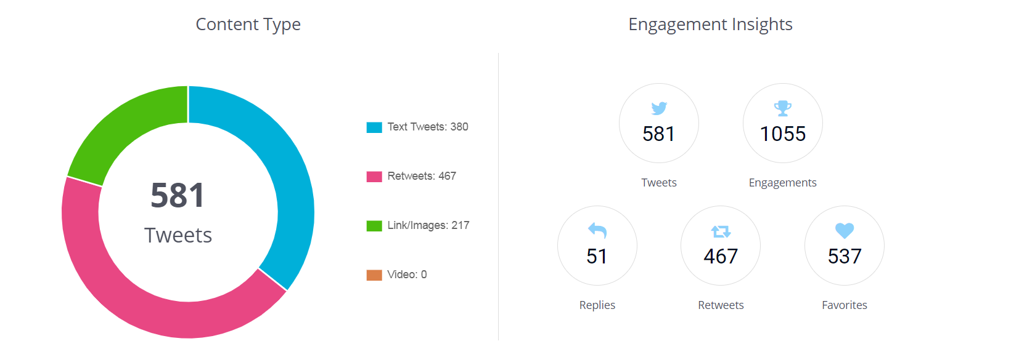

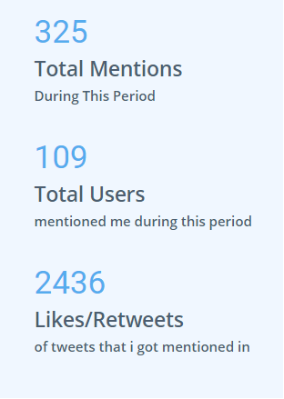

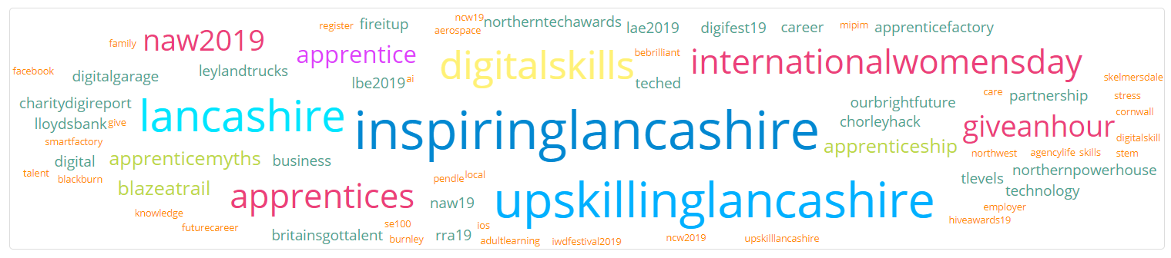

7.2 Press releases were issued for the Give an Hour campaign, as reported under section 1.5.

7.3 Press releases have also been issued for the ESFA opt-in Projects.

**8. Digital Skills Partnership**

8.1 The proposal to sign the Tech Talent Charter (TTC) was presented to the LEP Board along with an update on the Lancashire Digital Skills Partnership in early May. The board agreed to sign the Tech Talent Charter and that has now been actioned. The LDSP and Lancashire LEP are the first digital skills partnership and LEP to sign the charter and are leading the way. Appropriate media coverage is being planned with TTC. The LEP were very positive about the work of the LDSP and reported that the LDSP had received positive feedback at the LEP Network Chairs and CEOs Meeting from the Department for Digital, Media, Culture and Sport (DCMS).

8.2 The LEP Board also granted delegate authority to the interim Chief Executive, Andrew Pettinger, in consultation with the Section 151 Officer to review and sign off the business cases for the Digital Skills Innovation Fund projects as appropriate and agree and approve the entering into of grant funding agreements. We hope to complete this work by the end of the month and commence delivery shortly after. As reported at the last committee meeting, the projects aim to support unemployed into digital roles and support self-employed females and females in the workplace to develop their digital skills.

8.3 It has been agreed that the £3m fund announced by Government for the Greater Manchester Combined Authority (GMCA) for digital Bootcamps, which is a 'test and learn' programme for the National Retraining Scheme, will be expanded to cover Lancashire and the Digital Skills Partnership. Work is underway with DCMS and GMCA on the development of the prospectus and application process. Timescales are quite challenging, with the launch for the first call for funding requests set for Tuesday 25th June. It is likely that there will be 2 or 3 calls, depending on demand. Work is currently underway to socialise the programme with employers and providers, as it is anticipated that collaborative projects will be put forward for grant funding.

8.4 The Community of Practice event, 2nd July at County Hall, planned with charity One Digital is now open for bookings on Eventbrite [https://www.eventbrite.co.uk/e/developing-digital-skills-in-rural-communities-registration-61418447229?utm-medium=discovery&utm-campaign=social&utm-content=attendeeshare&utm-source=strongmail&utm-term=listing](https://www.eventbrite.co.uk/e/developing-digital-skills-in-rural-communities-registration-61418447229?utm-medium=discovery&utm-campaign=social&utm-content=attendeeshare&utm-source=strongmail&utm-term=listing#_blank). The focus of the event is developing digital skills in rural communities and will feature a variety of contributors including: Lancashire Adult Learning, Superfast Lancashire, Citizens Online (Gwynedd and Highlands projects), Age UK, Clackmannanshire Third Sector Interface, Sharon Wagg - Loughborough University, Lincoln University, Lancaster University, Community Futures and Lancashire Library Services.

**List of Background Papers**

|  |  |  |
| --- | --- | --- |
| Paper | Date | Contact/Tel |
| N/A |  |  |
| Reason for inclusion in Part II, if appropriate | | |

1. Previous reporting figure